-- Query 1

SELECT * FROM crime_scene_report WHERE city = "SQL City"

AND date = "20180115" AND type = "murder";

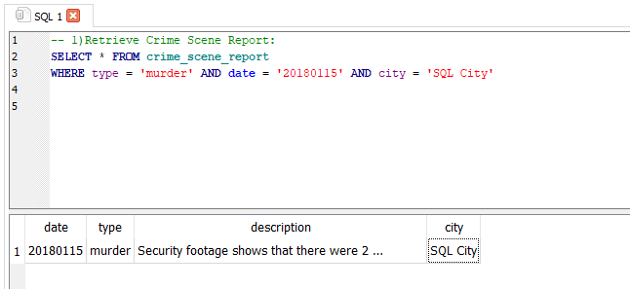

-- Query 2

SELECT * FROM person WHERE name LIKE 'Annabel%'

AND address_street_name LIKE 'Franklin Ave';

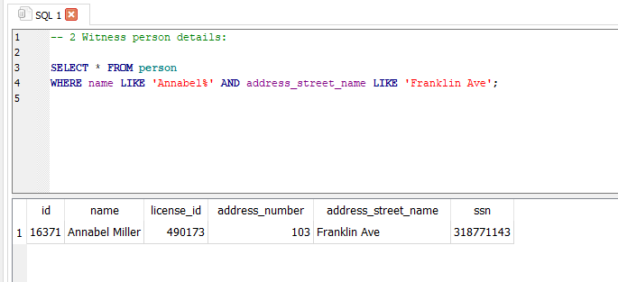

-- Query 3

SELECT * FROM person WHERE address_street_name LIKE 'Northwestern Dr'

ORDER By address_number DESC LIMIT 1;

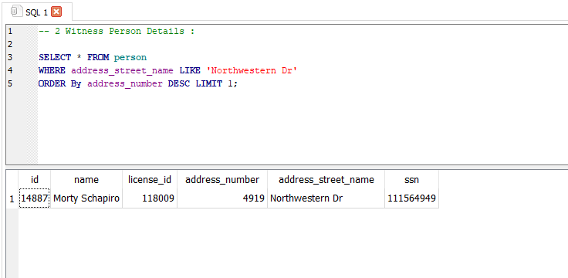

-- Query 4

SELECT * FROM interview WHERE person_id = 14887;

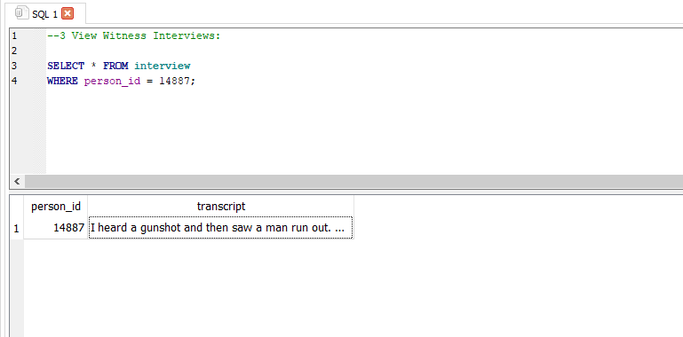

-- Query 5

SELECT * FROM interview WHERE person_id = 16371;

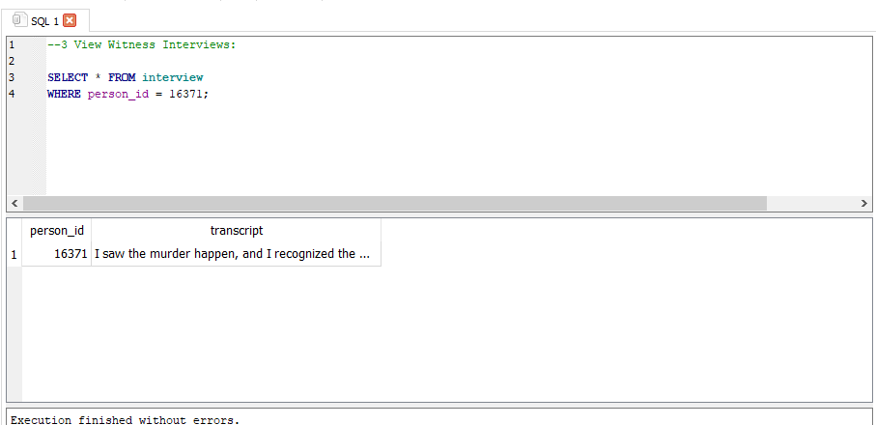

--Query 6

SELECT * FROM get_fit_now_check_in WHERE check_in_date LIKE '20180109'

AND membership_id LIKE '%48Z%';

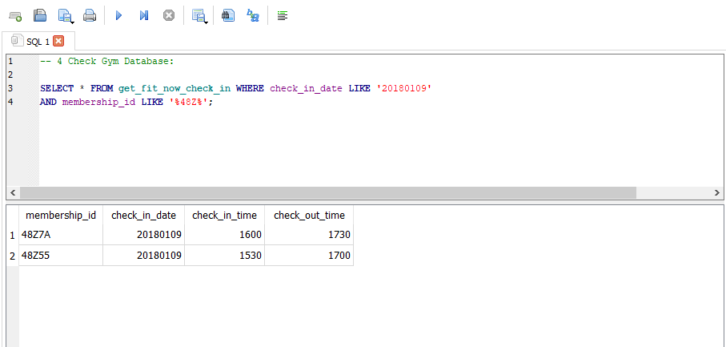

-- Query 7

SELECT * FROM get_fit_now_member WHERE id LIKE '%48Z%'

AND membership_status = 'gold';

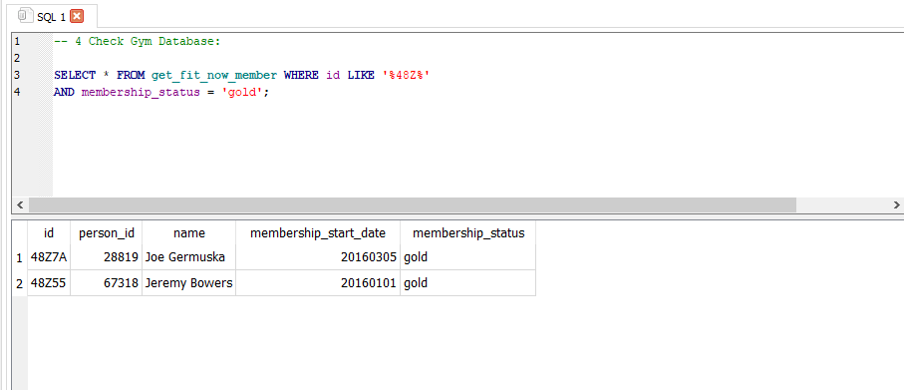

-- Query 8

SELECT * FROM drivers_license INNER JOIN person ON drivers_license.id = person.license_id

WHERE name = 'Joe Germuska' OR name = 'Jeremy Bowers';

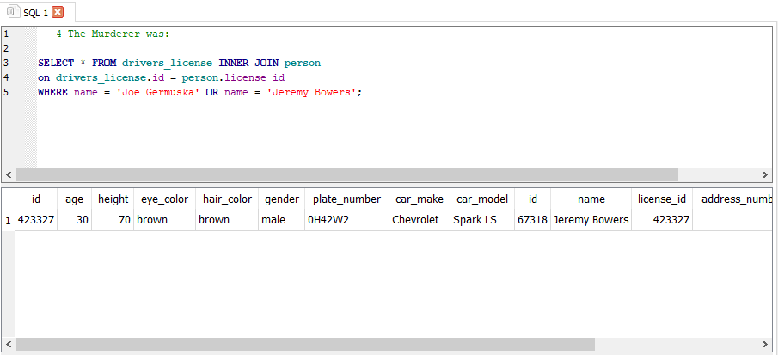

And we found the killer is Jeremy bowers but still we have to go deeper into the investigation.

After checking the suspect it still shows like this in the <https://mystery.knightlab.com/> so we have to still query it.

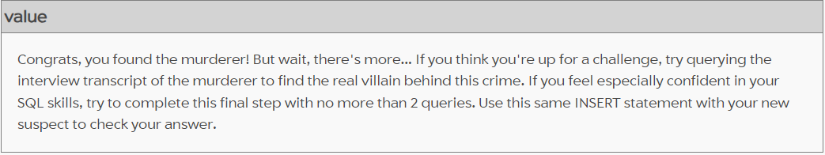

-- Query 9

SELECT p.name, d.height, d.hair_color, d.car_make, d.car_model, d.gender

FROM drivers_license AS d

JOIN person AS p ON d.id = p.license_id

WHERE d.height BETWEEN 65 AND 67

AND d.hair_color = 'red'

AND d.gender = 'female'

AND d.car_make = 'Tesla'

AND d.car_model = 'Model S'

AND p.id IN (SELECT f.person_id FROM facebook_event_checkin AS f WHERE f.event_name = 'SQL Symphony Concert');

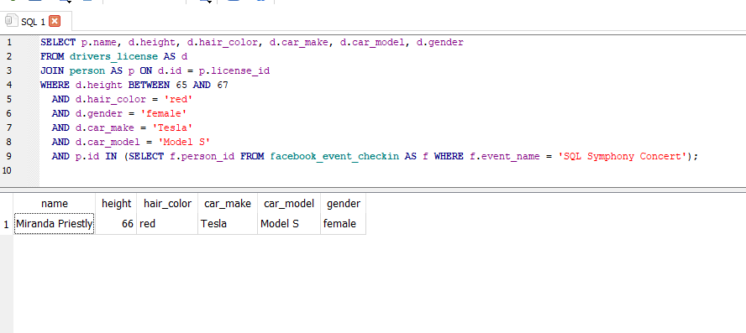

-- Query 10

INSERT INTO solution VALUES (1, 'Miranda Priestly');

SELECT value FROM solution;

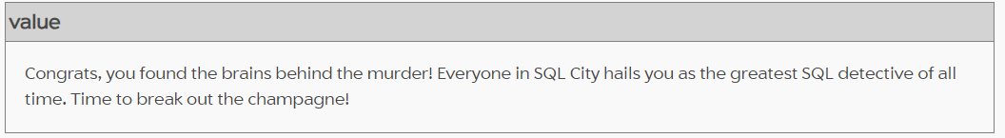

Thus we have found the murderer.